Test plan for
Medicinal Plant Identification

ChangeLog

Version | Change Date | By | Description
version number | Date of Change | Name of person who made changes | Description of the changes made
001 | 30.10.2002 | Mohammad Ausaf | Initial Draft

1 Introduction 2
1.1 Scope 2
1.1.1 In Scope 2
1.1.2 Out of Scope 2
1.2 Quality Objective 2
1.3 Roles and Responsibilities 2
2 Test Methodology 3
2.1 Overview 3
2.2 Test Levels 3
2.3 Bug Triage 3
2.4 Suspension Criteria and Resumption Requirements 3
2.5 Test Completeness 4
3 Test Deliverables 4
4 Resource & Environment Needs 4
4.1 Testing Tools 4
4.2 Test Environment 4
5 Terms/Acronyms 5

Introduction
Medicinal plants leaves have long been utilized in traditional medicine. Identification of medicinal leave is a very challenging task without external resources or assistance. Identification of the right medicinal plants that are used for the preparation of medicines is important in the medicinal industry. In various countries, there is a trend toward using traditional plant-based medicines alongside pharmaceutical drugs. Therefore, there seems to be immense potential in this field. Various kinds of algorithms are integrated into the application software. Image analysis is one important method that helps segment image into objects and background. One of the key steps in image analysis is feature detection. Transforming the input data into the set of features is called feature extraction. The image processing nowadays have become the key technique for the diagnosis of various features of the plant.

Scope

In Scope

Scope defines the features, functional or non-functional requirements of the software that will be tested.
Features of the Project:

1. Image Upload and Recognition: Functional Requirements
- Test the functionality of uploading images.
- Including Image format Verification and Validation.
- Ensure the recognition and identification accuracy of medicinal plants and materials.

2. Detailed Descriptions: Non-Functional Requirements
- Verify that detailed descriptions of recognized plants/materials are provided accurately.

3. Deep Learning Recognition: Functional Requirements
- Test the deep learning recognition algorithms for accuracy and reliability.

4. Machine Learning Model: Functional Requirements
- Ensure the machine learning model (e.g., ResNet-50) performs accurately for image classification.

5. User-Friendly Interface: Non-Functional Requirements
- Usability testing to evaluate the user interface for intuitiveness and ease of interaction.

6. Cross-Platform Accessibility: Functional Requirements
- Test the platform on various web browsers and devices for compatibility.

7. Reliable Cross-Browser Compatibility: Functional Requirements
- Ensure the web-based interface is compatible with popular web browsers.

8. Early Stopping Mechanism: Functional Requirements
- Test the early stopping mechanism in the machine learning model to prevent overfitting.

Out of Scope

Out Of Scope defines the features, functional or non-functional requirements of the software that will NOT be tested :

1. Cloud Computation Offloading:
- Ensure that computational tasks are efficiently offloaded to the cloud for smooth performance on client devices.

2. Scalability and Cloud Hosting:
- Load testing to ensure the platform can handle increased user loads efficiently when hosted on the cloud.

3. Custom Knowledge Database:
- Ensure the database provides accurate and reliable descriptions and context to users.

Quality Objective

Here make a mention of the overall objective that you plan to achive without your testing

Some objectives of your testing project could be

- Ensure the Application Under Test conforms to functional and non-functional requirements
- Ensure the AUT meets the quality specifications defined by the client
- Bugs/issues are identified and fixed before go live

Roles and Responsibilities
Detail description of the Roles and responsibilities of different team members like
- QA Analyst : Mohammad Ausaf
- Test Manager : Prof. Abhishek Goyal
- Configuration Manager: Prof. Akansha Mishra
- Developers : Mohammad Ausaf, Harsh Agrahari, Rahul Yadav
- Installation Team :Prof. Abhishek Goyal, Prof. Akansha Mishra, Mohammad Ausaf, Harsh Agrahari, Rahul Yadav

Test Methodology

Overview

We are using an iterative testing approach to make sure our project works well. This means we test it in small steps, starting with checking if each part works on its own. Then, we see how different parts work together.
We keep testing as we make changes and add new things. This way, we make sure our project is always working well, even after modification.

Test Levels

Test Levels define the Types of Testing to be executed on the Application Under Test (AUT). The Testing Levels primarily depends on the scope of the project, time and budget constraints.

Test Completeness
Here you define the criterias that will deem your testing complete.
For instance, a few criteria to check Test Completeness would be
- 100% test coverage
- All Manual & Automated Test cases executed
- All open bugs are fixed or will be fixed in next release

Test Deliverables

Test cases: -

Test Case | Test Objective | Test Data | Expected Result |  | Actual Result | Pass/Fail
1 | Model Training | Training data with plant leaf images and style images | Model converges, successfully learns plant leaf detection |  | Model successfully learns style transfer | Pass
2 | Inference | Test images (256x256 pixels) with varying content and styles | Generated images (256x256 pixels) exhibit desired style while retaining content |  | Generated images (256x256 pixels) exhibit desired style while retaining content | Pass
3 | Content Preservation | Generated plant leaf images | Content remains recognizable |  | Content recognizable | Pass
4 | Application Compatibility | Provide image not in .csv file | Handles file |  | Handles file | Pass
5 | Validate content layer | Sample plant leaf images, pre-trained model weights | Content layer produces expected feature maps |  | Content layer produces expected feature maps | Pass
6 | Validate style layer | Sample style images, pre-trained model weights | Style layer produces expected Gram matrices |  | Style layer produces expected Gram matrices | Pass
7 | Verify style transfer accuracy | Input images (256x256 pixels) with known content and style | Output images (256x256 pixels) match the desired style and content |  | Output images (256x256 pixels) match the desired style and content | Pass
8 | Verify data security | Testing with simulated security breaches | No unauthorized access or data breaches detected |  | Unauthorized  User can  not login | Pass
9 | Assess the impact of updates | System before and after updates | Previously tested features still work as expected |  | Previously tested features worked accurately | Pass
10 | Image Size Verification | Test images (256x256 pixels) of various sizes | Generated images (256x256 pixels) maintain aspect ratio and leaf plant content using a 3x3 kernel |  | Aspect ratio preserved; content recognizable using a 3x3 kernel | Pass

Requirement Traceability Matrix

Requirement ID | Requirement Description | Test Case ID(s) | Test Level
1 | Resnet50 algorithm | TC-001 | Unit
2 | User-friendly interface | TC-002 | Usability
3 | Real-time processing | TC-002 | Performance
4 | Compatibility with browsers | TC-002, TC-003 | Compatibility
5 | Data security measures | TC-003 | Security

Test Case Output Image:
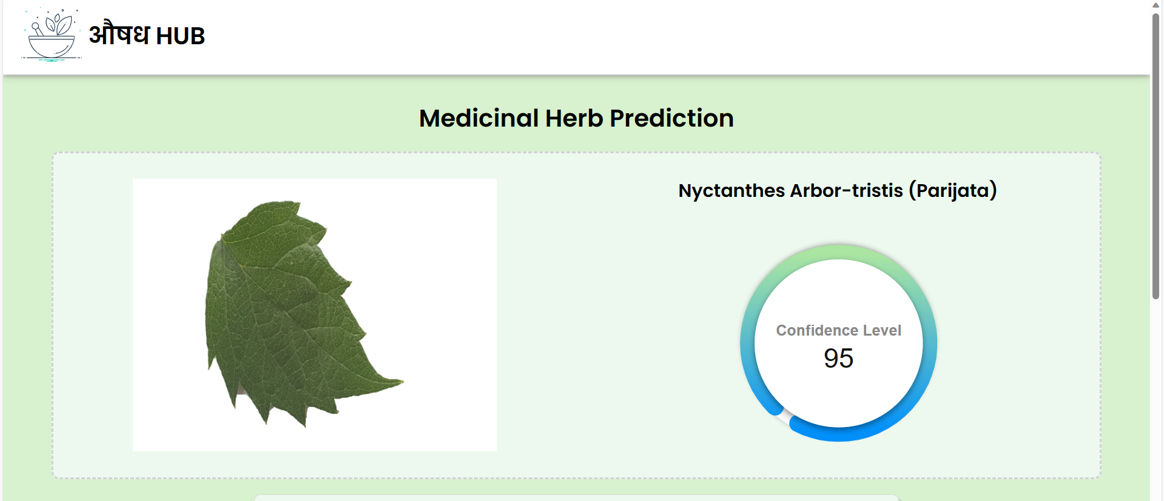

Resource & Environment Needs

Testing Tools

List of Tools like
- Selenium
- Mentis BT
- Automation Tool
Required to test the project

Test Environment
It mentions the minimum hardware requirements that will be used to test the Application.

Following software’s are required in addition to client-specific software.

- Windows 10 and above preferred
- VSCode 2022 or above preferred
- Chrome, Mozilla or Edge Preferred over non-chromium based browsers

Terms/Acronyms
Make a mention of any terms or acronyms used in the project

TERM/ACRONYM | DEFINITION
API | Application Program Interface
AUT | Application Under Test

